DigiBEST - LATVIA
Survey Analysis

Table of Content
Introduction 2
General overview 3
Opinion of enterprises on digitalization 7
Use of the ICT and digitalization by enterprises 9
Use of the Internet connection 9
Use of the digital technologies 10
Use of IT solutions and services 13
Use of the internet banking, public service portals and free public electronic tools 16
Use of the e-commerce 17
Use of the social media platforms 20
Cyber security, digital skills and digital strategy 21
Use of the digital security solutions 21
Corporative digitalization strategy 23
Digital skills of employees 24
Results of evaluation and solutions for the digital transformation of enterprises 25
Summary 27
Main Conclusions 30
Policy recommendations 31
Annex 1. DigiBEST survey questions 34
Annex 2. Definitions used in the survey 44

Introduction

According to the DigiBEST approach specified in the Application form the six project partner regions shall conduct the business digital transformation assessment on-line surveys (BDTAT) as a part of the regional research with a special attention to small/micro business organizations, which have specific requirements and access fewer support instruments. Results of the surveys shall contribute to conclusions and recommendations of the regional research, as well as bring an added value for partners’ business digitalization road maps (BDRM) and Action Plans for targeting SMEs digital transformation processes.

The first draft of the survey was designed by the DigiBEST Advisory partner – University of Latvia and sent to all project partners for comments. The next survey draft was discussed at the first DigiBEST partner meeting in Penafiel, Portugal on 12 December 2019. After that the basis for the survey was created and agreed among the partnership. The survey questions were further discussed and revised at the Latvian meeting of DigiBEST stakeholders on 7th January 2020. The survey was finalized and once again circulated to the Latvian DigiBEST stakeholders’ group and DigiBEST partnership during February 2020. During March and April 2020 the survey with a list of definitions and a cover letter were translated in project partners’ languages, the survey platform (QuestionPro) was identified and the test survey launched on-line. After testing and adjusting the on-line survey, and identifying respondents of the survey, it was finalized and sent out to SMEs and micro-enterprises, as well as released in media and social networks.

The main objective of the DigiBEST project survey is to evaluate the digital transformation performance of SMEs, as well as to draw conclusions for facilitating their digitalisation, which has become especially critical during the Covid19 pandemic crisis.

This survey is designed to answer four main questions:
- How small and medium businesses (SMEs) proceed towards the digital transformation?
- Why and which digitalization solutions are being mostly used by SMEs?
- Why businesses don’t use particular IT solutions or technologies?
- How authorities can help businesses to promote the digital transformation process?
This survey is designed for enterprise’s managerial level members (owner, manager, member of the management group, head of department or unit – one person per enterprise). All answers are anonymous, except, if a respondent chooses to provide a website of her enterprise in the introductory part of the survey. In order to get reliable results, the survey has the following participation criteria:
- SMEs with at least 3 years of work experience;
- More than 1 employee per enterprise;
- At least EUR 10 000 annual turnover over the last budget year;
- No IT, technology or communication enterprises should participate in the survey.
Enterprises which doesn’t comply with the above-mentioned criteria are asked not to participate or their responses aren’t taken into account.
The DigiBEST survey is structured into two main parts. The first part of the survey is the General overview, where respondents have to agree that they confirm to the data protection regulations and answer if they want to get introduced with specific terms used in the survey. Also, respondents have to provide a general information about themselves (number of employees, annual turnover, sector of activity, place of activity). Respondents are also asked to provide their website addresses if they are interested to get a feedback after completing the survey, as well as participate in a special competition for the main prize – participation in the DigiBEST study visit to one of the partner’s regions where the next study visit will be organised to learn about the best digital transformation practices.

The second part of the survey tackles the digital transformation process of SMEs, their understanding of the use of digital tools and solutions, as well as their use, level of digital skills and existence of digitalisation strategies and digital security solutions, and other digitalisation aspects. The survey also provides a list of definitions of digitalization terms. In total, the survey contains 8 introductory questions and 15 questions on digitalization with choices of answers. Please, see the survey questions attached (Annex 1).

The survey in Latvia was conducted from 18 May to 29 June 2020. Therefore, it has been particularly influenced by the Covid19 pandemic crisis which promoted the use of digital tools and solutions as many businesses, state institutions, schools and universities were forced to work remotely.

This has been planned that the results of survey will be used for research purposes leading to conclusions and recommendations to be used for policy documents to promote the digital transformation, as well as for dissemination objectives of the DigiBEST project.

This comparative analysis is based on data analysis and survey results leading to conclusions and policy recommendations, which are designed additionally using other resources of the DigiBEST project, such as good practices, and authors’ own knowledge, to complement the DigiBEST Regional Study on the State of Digital Transformation and its Impact on the Regional Businesses implemented by the Ministry for Environmental Protection and Regional Development of the Republic of Latvia (VARAM).

General overview

In total, 86 persons started filling in the DigiBEST survey. However, complete answers to all 15 survey questions were provided by 51 respondents. 29 participants only confirmed the data protection regulations and answered if they want to get introduced with specific terms used in the survey but didn’t continue the survey. Other 57 respondents continued the survey and fully completed the General overview part. After that one person dropped out and 56 respondents continued filling the survey until the question 7 (Which of the following digital technologies are you planning to introduce in your business during the next 3 years?). The 7th question was answered by 52 respondents, while the rest of answers, starting from 8th question (Which of the following IT solutions and services are you planning to start using in your business during the next 3 years?), were fully answered by 51 respondents. The target of the survey was to have at least 50 responses, which was fulfilled.

Reasons of not completing the survey can be partially related to not corresponding to survey criteria with respect to size or specialization of the enterprise or found it irrelevant for some reason. All responses are taken into account analysing the survey taking into account that the analysis looks at percentages not numbers and that answers to one question don’t have to be compared with answers to other questions.

In total, 439 persons viewed the survey. The completion rate is 59.3% and the average time to complete the survey was 11 minutes.

All survey respondents agreed that they confirm to the data protection regulations.

Most of respondents or 73.3% (63 of 86) expressed interest to get introduced with the digitalization terminology and definitions being used in the survey.

Almost all respondents (56 of 57 or 98%), except one, represent SMEs: 47 (82%) of all 57 respondents represent micro and small enterprises (1 to 10 employees); 8 enterprises (14%) have from 11 to 50 employees; one enterprise has from 101 to 200 employees; and one enterprise has more than 250 employees (answer – other).

Picture 1. Size of enterprises represented in the survey by number of employees 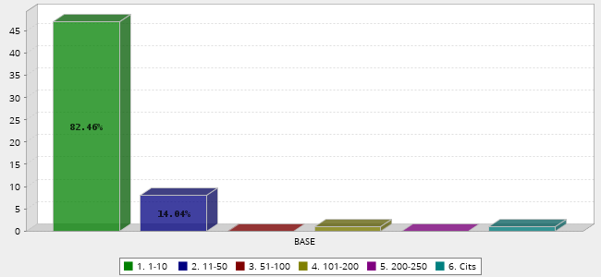
Table 1. Distribution of enterprises by number of employees
No | Answer | Count | Percent
1 | 1-10 | 47 | 82.46%
2 | 11-50 | 8 | 14.04%
3 | 51-100 | 0 | 0.00%
4 | 101-200 | 1 | 1.75%
5 | 200-250 | 0 | 0.00%
6 | Other | 1 | 1.75%
 | Total | 57 | 100%
Majority of enterprises (36.8% or 21 of 57) participating in the survey have annual turnover from EUR 10 000 to EUR 30 000; the other biggest group (24.6% or 14 of 57) enterprises have their annual turnover from EUR 30 000 to 100 000; 14.4% or 8 enterprises of 57 have their annual turnover up to EUR 10 000; 10.5% or 6 enterprises of 57 have their annual turnover from EUR 100 000 to EUR 500 000; 1 enterprise of 57 has its annual turnover from EUR 500 000 to 1 000 000; and 12% or 7 enterprises of 57 have their turnover above one million euros.
Picture 2. Size of enterprises represented in the survey by turnover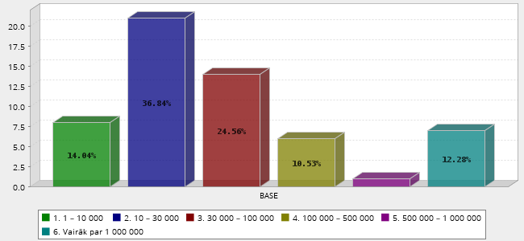
Table 2. Distribution of enterprises by turnover
No | Answer | Count | Percent
1 | 1 – 10 000 | 8 | 14.04%
2 | 10 – 30 000 | 21 | 36.84%
3 | 30 000 – 100 000 | 14 | 24.56%
4 | 100 000 – 500 000 | 6 | 10.53%
5 | 500 000 – 1 000 000 | 1 | 1.75%
6 | Over 1 000 000 | 7 | 12.28%
 | Total | 57 | 100%
Enterprises participating in the survey represent various sectors of economy except the ICT sector. The two largest groups or 32% with 9 enterprises each (18 of 57) represent the services sector and the tourism, entertainment and hospitality sector. Please, see Picture 3 and Table 3.
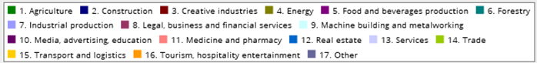
Picture 3. Distribution of enterprises by sectors of economy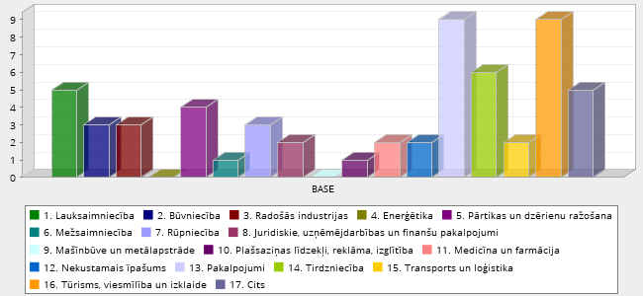
Table 3. Distribution of enterprises by sectors of economy
No | Answer | Count | Percent
1 | Agriculture | 5 | 8.77%
2 | Construction | 3 | 5.26%
3 | Creative industries | 3 | 5.26%
4 | Energy | 0 | 0.00%
5 | Food and beverages | 4 | 7.02%
6 | Forestry | 1 | 1.75%
7 | Manufacturing | 3 | 5.26%
8 | Legal, business and financial services | 2 | 3.51%
9 | Machine building and metalworking | 0 | 0.00%
10 | Media, advertising and education | 1 | 1.75%
11 | Medicine and pharmacy | 2 | 3.51%
12 | Real estate | 2 | 3.51%
13 | Services | 9 | 15.79%
14 | Trade | 6 | 10.53%
15 | Transport and logistics | 2 | 3.51%
16 | Tourism, hospitality and entertainment | 9 | 15.79%
17 | Other | 5 | 8.77%
Almost half of participants or 47% or 27 of 57 enterprises are from the Riga region, where the economic activity is greater than elsewhere in Latvia. However, other 4 regions are represented in the survey as well by 23% or 13 of 57 enterprises from the Zemgale region, 14% or 8 of 57 enterprises of 57 are from the Kurzeme region, 11% or 6 of 57 enterprises are from the Latgale region, and 5% or 3 of 57 enterprises are from the Vidzeme region.
Picture 4. Distribution of enterprises by region
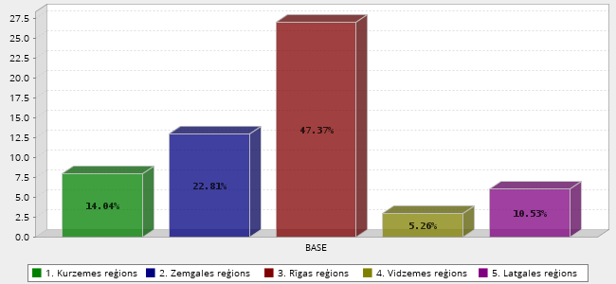
Table 4. Distribution of enterprises by region
No | Answer | Count | Percent
1 | Kurzemes region | 8 | 14.04%
2 | Zemgales region | 13 | 22.81%
3 | Rigas region | 27 | 47.37%
4 | Vidzemes region | 3 | 5.26%
5 | Latgales region | 6 | 10.53%
 | Total | 57 | 100%

Opinion of enterprises on digitalization

Majority of enterprises or 98% or 55 of 56 enterprises agree that they could benefit from the digitalization. However, 2% or 1 of 56 enterprises thinks that it wouldn’t have any benefits from the digitalization.

The four most important benefits, which enterprises expect from the digitalization are new clients (16%), increased turnover and profits (14%) and increased recognition for their businesses (13%), and improved experience of their customers (services) – 12%. Please, see Picture 5 and Table 5 about all benefits, which enterprises consider as benefits from the digitalization.

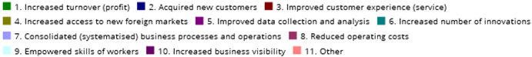
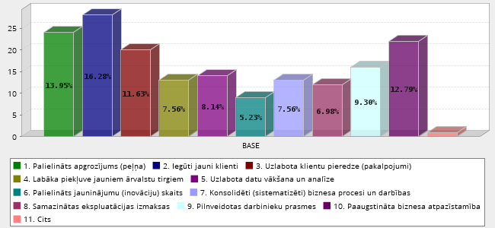
Picture 5. Benefits of digitalization
Table 5. Benefits of digitalization
No | Answer | Count | Percent
1 | Increased turnover (profit) | 24 | 13.95%
2 | Acquired new customers | 28 | 16.28%
3 | Improved customer experience (service) | 20 | 11.63%
4 | Increased access to new foreign markets | 13 | 7.56%
5 | Improved data collection and analysis | 14 | 8.14%
6 | Increased number of innovations | 9 | 5.23%
7 | Consolidated (systemized) business processes and operations | 13 | 7.56%
8 | Reduced operating costs | 12 | 6.98%
9 | Empowered skills of workers | 16 | 9.30%
10 | Increased business visibility | 22 | 12.79%
11 | Other | 1 | 0.58%
 | Total | 172 | 100%
The only enterprise which think that there aren’t any benefits from the digitalization as the main obstacles mentions lack of infrastructure and lack of budget.

Use of the ICT and digitalization by enterprises

Use of the Internet connection
Almost equal part of enterprises – 43% or 24 of 56 enterprises use mobile internet connection and 41% or 23 of 56 enterprises use fast speed broadband connection or optical internet in their work. Other internet connections used are fixed telephone line connection – 5% or 3 of 56 enterprises, cable connection – 5% or 3 of 56 enterprises, satellite connection – 2% or 1 of 56 enterprises, or other types of connection – 4% or 2 of 56 enterprises.
Picture 6. Type of the internet connection used by enterprises 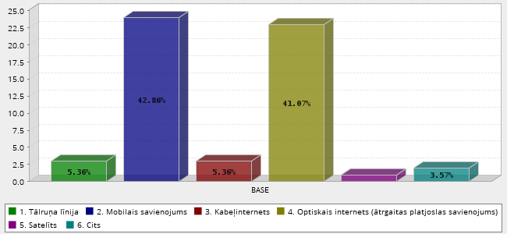
Table 6. Type of the internet connection used by enterprises
No | Answer | Count | Percent
1 | Phone line | 3 | 5.36%
2 | Mobile connection | 24 | 42.86%
3 | Cable internet | 3 | 5.36%
4 | Optical Internet connection (high-speed broadband connection) | 23 | 41.07%
5 | Satellite | 1 | 1.79%
6 | Other | 2 | 3.57%
 | Total | 56 | 100%
The majority of enterprises – 84% or 47 of 56 enterprises consider that their internet connection is sufficient for their daily business needs. However, some enterprises think that the internet connection they are using is too slow – 4% or 2 of 56 enterprises or that the internet connection could be faster, but they can’t afford to pay for it – in case of 4% or 2 of 56 enterprises. 5% or 3 of 56 enterprises answer that their internet connection is insufficient for their daily business needs, because the right infrastructure isn’t in place. Another 4% or 2 of 56 enterprises answered that in a case of necessity they can obtain faster internet connection.

Use of the digital technologies
Answering the question about the top 3 digital technologies used, the vast majority – 33% or 38 of 56 enterprises answered that they use wireless technologies. Other top 4 technologies used are Cloud data services marked by 18% or 21 of 56 enterprises; security (scripting) technologies – 10% or 12 of 56 enterprises; data basis technologies – 7% or 8 of 56 enterprises. Other technologies used by enterprises are automatisation technologies – 6% or 7 of 56 enterprises; data visualization technologies – 6% or 7 of 56 enterprises and others – 2% or 2 of 56 enterprises (see Picture 7 and Table 7).
4% of 5 of 56 enterprises have answered that they don’t use any of the abovementioned digital technologies. However, they haven’t mentioned any of reasons, why they don’t use these technologies or, which technologies they are using instead.

Picture 7. Digital technologies used by enterprises
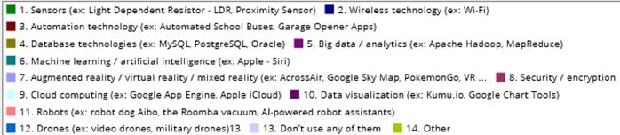
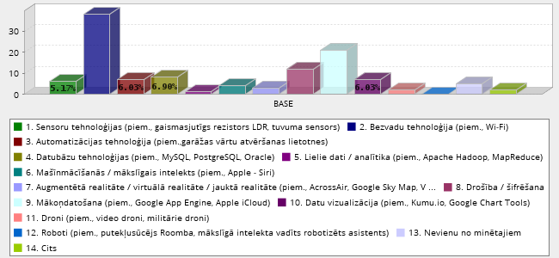
Table 7. Digital technologies used by enterprises.
No | Answer | Count | Percent
1 | Sensor (ex: Light Dependent Resistor - LDR, Proximity Sensor) | 6 | 5.17%
2 | Wireless technology (ex: Wi-Fi) | 38 | 32.76%
3 | Automation technology (ex: Automated School Buses, Garage Opener Apps) | 7 | 6.03%
4 | Database technologies (ex: MySQL, PostgreSQL, Oracle) | 8 | 6.90%
5 | Big data / analytics (ex: Apache Hadoop, MapReduce) | 1 | 0.86%
6 | Machine learning / artificial intelligence (ex: Apple - Siri) | 4 | 3.45%
7 | Augmented reality / virtual reality / mixed reality (ex: AcrossAir, Google Sky Map, PokemonGo, VR glasses) | 3 | 2.59%
8 | Security / encryption | 12 | 10.34%
9 | Cloud computing (ex: Google App Engine, Apple iCloud) | 21 | 18.10%
10 | Data visualization (ex: Kumu.io, Google Chart Tools) | 7 | 6.03%
11 | Robots (ex: robot dog Aibo, the Roomba vacuum, AI-powered robot assistants) | 0 | 0.00%
12 | Drones (ex: video drones, military drones) | 2 | 1.72%
13 | Don’t use any of them | 5 | 4.31%
14 | Other | 2 | 1.72%
 | Total | 116 | 100%
Most of respondents – 87% or 44 of 56 enterprises were quite positive and interested in introducing the abovementioned digital technologies in their businesses during the nearest 3 years, while 13% or 12 of 56 enterprises have answered that they aren’t planning to introduce any of the abovementioned technologies in their businesses. For those interested in introducing new technologies in their businesses the five most desired digital technologies are: databases technologies (15%); big data / analytics (11%); security / scripting (13); wireless technologies (11%). Other choices, please, see in the Picture 8 and Table 8.
Table 8. Digital technologies planned to be introduced in businesses during the next three years
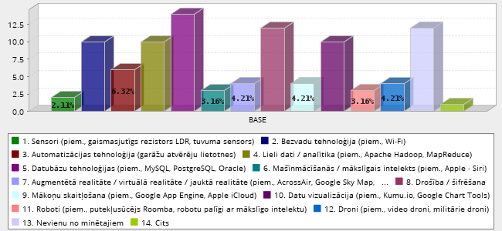
Table 8. Digital technologies planned to be introduced in businesses during the next three years
No | Answer | Count | Percent
1 | Sensors (ex: Light Dependent Resistor - LDR, Proximity Sensor) | 2 | 2.11%
2 | Wireless technology (ex: Wi-Fi) | 10 | 10.53%
3 | Automation technology (ex: Automated School Buses, Garage Opener Apps) | 6 | 6.32%
4 | Database technologies (ex: MySQL, PostgreSQL, Oracle) | 14 | 14.74%
5 | Big data / analytics (ex: Apache Hadoop, MapReduce) | 10 | 10.53%
6 | Machine learning / artificial intelligence (ex: Apple - Siri) | 3 | 3.16%
7 | Augmented reality / virtual reality / mixed reality (ex: AcrossAir, Google Sky Map, PokemonGo, VR glasses) | 4 | 4.21%
8 | Security / encryption | 12 | 12.63%
9 | Cloud computing (ex: Google App Engine, Apple iCloud) | 4 | 4.21%
10 | Data visualization (ex: Kumu.io, Google Chart Tools) | 10 | 10.53%
11 | Robots (ex: robot dog Aibo, the Roomba vacuum, AI-powered robot assistants) | 3 | 3.16%
12 | Drones (ex: video drones, military drones) | 4 | 4.21%
13 | Don’t use any of them | 12 | 12.63%
14 | Other | 1 | 1.05%
 | Total | 95 | 100%
Thirteen (13%) or 12 of 56 enterprises answered that they aren’t planning to introduce any of the above mentioned digital technologies in their businesses mentioning the following reasons: 1) because they aren’t needed for their enterprises – 9% or 5 of 56 enterprises; 2) they aren’t sure if this is necessary - 9% or 5 of 56 enterprises; 3) they are too complicated – 2% or 5 of 56 enterprises; 4) they don’t have enough information about these technologies - 2% or 5 of 56 enterprises.

Use of IT solutions and services
Answering the question about the use of IT solutions and services, the four most commonly used were: data storage (28%); data clouding services (21%); on-line service solutions (13%); automatic generation of e-invoices (10%); SEO solutions (9%). The other IT solutions and services used by respondents are reflected in the Picture 9 and Table 9.

Picture 9. IT solutions and services used by enterprises
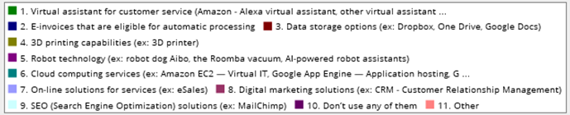
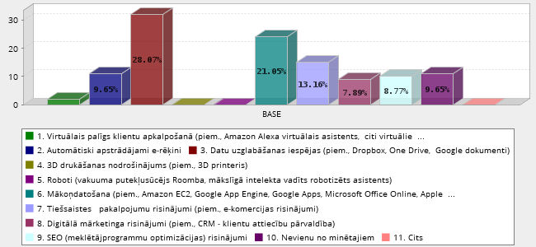
Table 9. IT solutions and services used by enterprises
No | Answer | Count | Percent
1 | Virtual assistant for customer service (Amazon - Alexa virtual assistant, other virtual assistants) | 2 | 1.75%
2 | E-invoices that are eligible for automatic processing | 11 | 9.65%
3 | Data storage options (ex: Dropbox, Google Docs) | 32 | 28.07%
4 | 3D printing capabilities (ex: 3D printer) | 0 | 0.00%
5 | Robot technology (ex: robot dog Aibo, the Roomba vacuum, AI-powered robot assistants) | 0 | 0.00%
6 | Cloud computing services (ex: Amazon EC2 — Virtual IT, Google App Engine — Application hosting, Google Apps and Microsoft Office Online — SaaS, Apple iCloud — Network storage) | 24 | 21.05%
7 | On-line solutions for services (ex: eSales) | 15 | 13.16%
8 | Digital marketing solutions (ex: CRM - Customer Relationship Management) | 9 | 7.89%
9 | SEO solutions (ex: MailChimp) | 10 | 8.77%
10 | Don’t use any of them | 11 | 9.65%
11 | Other | 0 | 0.00%
 | Total | 114 | 100%
20% or 11 of 56 enterprises have answered that they aren’t using any of the abovementioned IT solutions or services. The reasons of the non-use are the following: 1) 9% or 5 of 56 enterprises have indicated that these IT solutions or services are too expensive; 2) 4% or 2 of 56 enterprises answered that they aren’t needed for their businesses; 3) 4% or 2 of 56 enterprises aren’t sure if they are necessary; 4) 2% or 1 of 56 enterprises considers that they are too complicated; 5) 2% or 1 of 56 enterprises answered that they don’t have employees that have necessary skills for using these IT solutions or services.
Answering a question about the IT solutions or services planned to be introduced in businesses during the next 3 years, the most desired were the automatic generation of e-invoices (22%); on-line service solutions (14%); data clouding services (13%); data storage (12.5%) and others (please, see Picture 10 and Table 10).
9% or 5 of 56 enterprises have mentioned that they aren’t planning to introduce any of the above mentioned IT solutions or services because: 1) 2% or 1 of 56 enterprises think that they are too expensive; 2) another 2% or 1 of 56 enterprises aren’t sure if they are needed for their businesses; 2% or 1 of 56 enterprises, have indicated that they aren’t necessary for their business.
Picture 10. IT solutions or services planned to be introduced in businesses during the next three years
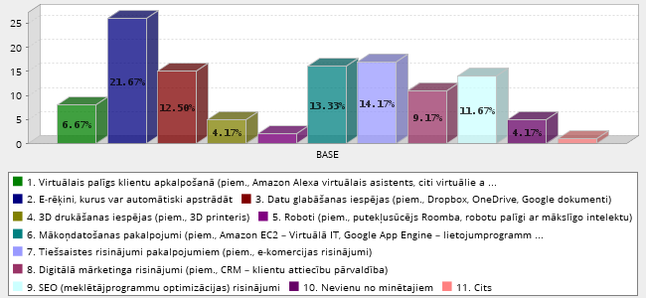

Table 10. IT solutions or services planned to be introduced in businesses during the next three years
No | Answer | Count | Percent
1 | Virtual assistant for customer service (Amazon - Alexa virtual assistant, other virtual assistants) | 8 | 6.67%
2 | E-invoices that are eligible for automatic processing | 26 | 21.67%
3 | Data storage options (ex: Dropbox, One Drive, Google Docs) | 15 | 12.50%
4 | 3D printing capabilities (ex: 3D printer) | 5 | 4.17%
5 | Robot technology (ex: robot dog Aibo, the Roomba vacuum, AI-powered robot assistants) | 2 | 1.67%
6 | Cloud computing services (ex: Amazon EC2 — Virtual IT, Google App Engine — Application hosting, Google Apps and Microsoft Office Online — SaaS, Apple iCloud — Network storage) | 16 | 13.33%
7 | On-line solutions for services (ex: eSales) | 17 | 14.17%
8 | Digital marketing solutions (ex: CRM - Customer Relationship Management) | 11 | 9.17%
9 | SEO (Search Engine Optimization) solutions (ex: MailChimp) | 14 | 11.67%
10 | Don’t use any of them | 5 | 4.17%
11 | Other | 1 | 0.83%
 | Total | 120 | 100

Use of the internet banking, public service portals and free public electronic tools
All 52 respondents (100%), which have answered the question about the use of internet banking, confirmed that they use it.

Answering a question about the use of public services 82% or 42 of 51 enterprises answered that they use these services, while 18% or 9 of 51 enterprises indicated that they don’t use public on-line services. Those, who use public services, mainly use the public services’ portal Latvija.lv – 41% or 34 of 51 enterprises; electronic signature – 34% or 28 of 51 enterprises and eID card – 23% or 19 of 51 enterprises. 2% or 1 of 51 enterprises indicated that they are using another service or tool, but didn’t specify, which one. (See Picture 11 and Table 11)

Picture 11. Use of public services’ portals or free public electronic tools
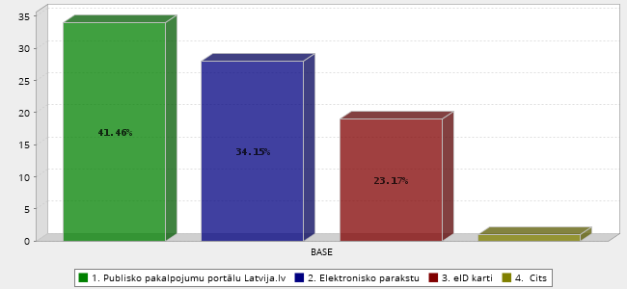
Table 11. Use of public services’ portals or free public electronic tools
No | Answer | Count | Percent
1 | Public services portal Latvija.lv | 34 | 41.46%
2 | Electronic signature | 28 | 34.15%
3 | eID card | 19 | 23.17%
4 | Other | 1 | 1.22%
 | Total | 82 | 100%
Those 18% or 9 of 51 enterprises which have answered that they aren’t using public services’ portals or free public electronic tools as main reasons for the non-use indicate: 1) they aren’t needed for businesses (4 responses); 2) lack of technical skills (3 responses); 3) not sure that this is necessary for business (1 response); 4) the policy of enterprise doesn’t require to use them (1 response). See Picture 12 and Table 12.
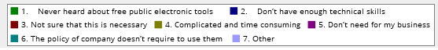
Picture 12. Reasons for non-use of public services’ portals or free public electronic tools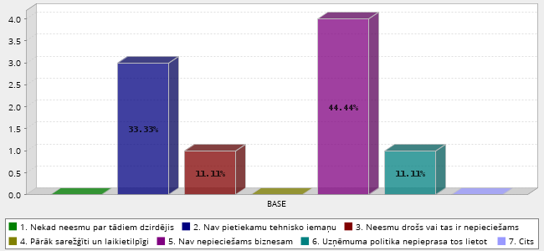

Table 12. Reasons for non-use of public services’ portals or free public electronic tools
No | Answer | Count | Percent
1 | Never heard about free public electronic tools | 0 | 0.00%
2 | Don’t have enough technical skills | 3 | 33.33%
3 | Not sure that this is necessary | 1 | 11.11%
4 | Complicated and time consuming | 0 | 0.00%
5 | Don’t need for my business | 4 | 44.44%
6 | The policy of enterprise doesn’t require to use them | 1 | 11.11%
7 | Other | 0 | 0.00%
 | Total | 9 | 100%

Use of the e-commerce
Most of respondents – 61% or 31 of 51 enterprises don’t use the e-commerce services to make orders on the Internet, while 39% or 20 of 51 enterprises use the e-commerce.

Those 20% or 12 of 51 enterprises, who use e-commerce services, mostly use them for placing orders on-line; 18% or 11 of 51 enterprises use the e-commerce services for receiving orders from clients on-line; 15% or 9 of 51 enterprises use these services for receiving orders on the website or application; another 15% or 9 of 51 enterprises use them for receiving orders on the computer. Also, in a case of 7% or 4 of 51 enterprises the e-commerce is being used for receiving orders through the EDE; another 7% or 4 of 51 enterprises use the e-commerce for placing electronic sales in own country; and 7% or 4 of 51 enterprises use it for placing electronic sales in foreign country; 8% or 5 of 51 enterprises use the e-commerce software solutions; 2% or 1 of 51 enterprises use the e-commerce services for purchasing computer networks from suppliers in own country; and other 2% or 1 of 51 enterprises use them for other purposes. Please, see Picture 13 and Table 13.

Picture 13. Purposes of the use of e-commerce
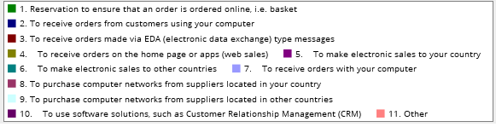
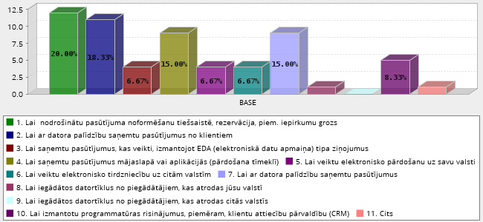
Table 13. Purposes of the use of e-commerce
No | Answer | Count | Percent
1 | Reservation to ensure that an order is ordered online, i.e. basket | 12 | 20.00%
2 | To receive orders from customers using your computer | 11 | 18.33%
3 | To receive orders made via EDA (electronic data exchange) type messages | 4 | 6.67%
4 | To receive orders on the home page or apps (web sales) | 9 | 15.00%
5 | To make electronic sales to your country | 4 | 6.67%
6 | To make electronic sales to other countries | 4 | 6.67%
7 | To receive orders with your computer | 9 | 15.00%
8 | To purchase computer networks from suppliers located in your country | 1 | 1.67%
9 | To purchase computer networks from suppliers located in other countries | 0 | 0.00%
10 | To use software solutions, such as Customer Relationship Management (CRM) | 5 | 8.33%
11 | Other | 1 | 1.67%
 | Total | 60 | 100%
Considering that most of entrepreneurs – 61% or 31 of 51 enterprises still don’t use opportunities provided by the e-commerce, this is especially important to find out reasons of the non-use of e-commerce services.
Unfortunately, most of the respondents – 38% or 14 of 51 enterprises decided not to choose any of the provided survey options and have chosen the answer “none of the above”. Most of the other respondents indicated that the main reason for the non-use of e-commerce is a lack of an overall e-commerce strategy (32%). Several other responses emphasised too high product delivery / return costs (11%); lack of foreign language knowledge (9%); problems with product labelling (3%), restrictions placed by business partners or clients (3%), safety concerns (3%) and other unspecified reasons (3%). Please, see Picture 14 and Table 14.
Picture 14. Purposes of the non-use of e-commerce
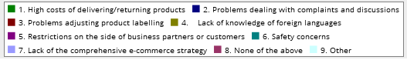
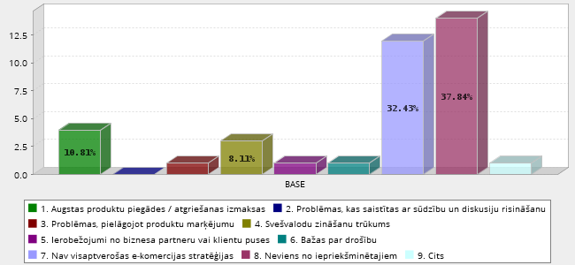
Table 14. Purposes of the non-use of e-commerce
No | Answer | Count | Percent
1 | High cost of delivery/return of products | 4 | 10.81%
2 | Problems dealing with complaints and discussions | 0 | 0.00%
3 | Problems adjusting product labelling | 1 | 2.70%
4 | Lack of knowledge of foreign languages | 3 | 8.11%
5 | Restrictions on the side of business partners or customers | 1 | 2.70%
6 | Safety concerns | 1 | 2.70%
7 | Lack of the comprehensive e-commerce strategy | 12 | 32.43%
8 | None of the above | 14 | 37.84%
9 | Other | 1 | 2.70%
 | Total | 37 | 100%

Use of the social media platforms
Most of respondents – 80% or 41 of 51 enterprises use the social media platforms for their businesses, while 20% or 10 of 51 enterprises don’t use them.

Those, who use social media platforms, prefer such social networks as Facebook, LinkedIn and others – 37% or 33 of 51 enterprises; own websites – 33% or 21 of 51 enterprises; blogs or microblogs, such as Twitter or Instagram – 14% or 13 of 51 enterprises; information storages, such as Google, Wikipedia and others – 11% or 10 of 51 enterprises; media co-working sites, such as You Tube, Slide Share and others – 4% or 4 of 51 enterprises; other unspecified platforms – 1% or 1 of 51 enterprises. Please, see Picture 15 and Table 15.

Picture 15. Use of the social media platforms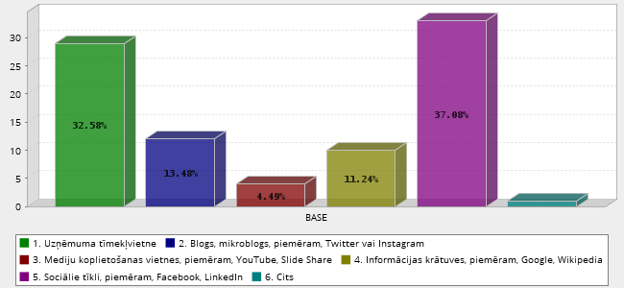
Table 15. Use of the social media platforms
No | Answer | Count | Percent
1 | Website of enterprise | 29 | 32.58%
2 | Blog, micro -blog such as Twitter or Instagram | 12 | 13.48%
3 | Media sharing sites like YouTube, Slide Share | 4 | 4.49%
4 | Information access networks such as Google, Wikipedia | 10 | 11.24%
5 | Social networks like as Facebook, LinkedIn | 33 | 37.08%
6 | Other | 1 | 1.12%
 | Total | 89 | 100%

Those 20% or 10 of 51 enterprises, which don’t use social media tools, as the main reasons of non-use indicate that they aren’t important for their businesses - 6% or 3 of 51 enterprises; aren’t sure if they are needed for their businesses – 6% or 3 of 51 enterprises; find it too complicated and time consuming – 4% or 2 of 51 enterprises; consider it too expensive – 2% or 1 of 51 enterprises; don’t have enough technical skills to use them - 2% or 1 of 51 enterprises.

Cyber security, digital skills and digital strategy

Use of the digital security solutions
Most of enterprises participating in the survey – 61% or 31 of 51 enterprises use the available digital security solutions, while 39% or 20 of 51 enterprises don’t use any of the digital security solutions.

Those, who use the digital security solutions, mainly use different prophylactic measures against on-line attacks - 22% or 19 of 51 enterprises; regular backups – 21% or 18 of 51 enterprises; other widely used security measure is the data protection on all devices – 20% or 17 of 51 enterprises. Other used tools are management of logins - 12% or 10 of 51 enterprises; defence of business servers and applications – 8% or 7 of 51 enterprises; protected devices – 8% or 7 of 51 enterprises; regular trainings of employees on cyber security – 7% or 6 of 51 enterprises. Nobody of respondents had a cyber-security strategy. Please, see Picture 16 and Table 16.

Picture 16. Use of the digital security solutions
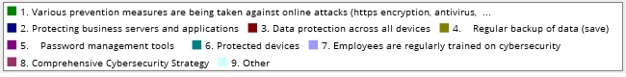
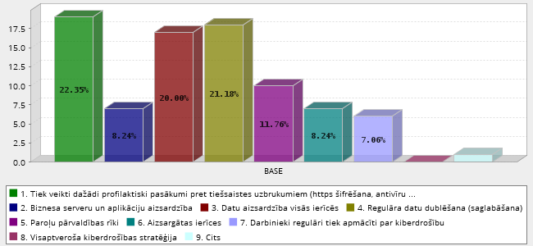

Table 16. Use of the digital security solutions
No | Answer | Count | Percent
1 | Various prevention measures are being taken against online attacks  (https encryption, antivirus, firewalls) | 19 | 22.35%
2 | Protecting business servers and applications | 7 | 8.24%
3 | Data protection on all devices | 17 | 20.00%
4 | Regular backup of data (save) | 18 | 21.18%
5 | Password management tools | 10 | 11.76%
6 | Protected devices | 7 | 8.24%
7 | Employees are regularly trained on cybersecurity | 6 | 7.06%
8 | Comprehensive Cybersecurity Strategy | 0 | 0.00%
9 | Other | 1 | 1.18%
 | Total | 85 | 100%

Those 39% or 20 of 51 enterprises, which don’t use any digital security solutions, mostly lack knowledge about digital security – 20% or 10 of 51 enterprises or consider it too complicated (lack skills and knowledge) – 4% or 2 of 51 enterprises. Others think that they can manage their businesses without any digital security solutions – 8 or 4 of 51 enterprises; never heard about digital security solutions – 6 or 3 of 51 enterprises; consider these solutions too expensive for their budget – 2% or 1 of 51 enterprises.

Corporative digitalization strategy
Most of enterprises participating in the survey or 71% or 36 of 51 enterprises don’t have any corporative digitalization strategy. Only 2% or 1 of 51 enterprises has fully functioning digitalization strategy; 10% or 5 of 51 enterprises have prepared the digitalization strategy on an enterprise level; and 16% or 8 of 51 enterprises are planning to develop their digitalization strategy within the next 3 years. Please, see Picture 17 and Table 17.
Picture 17. Existence of the digitalization strategy
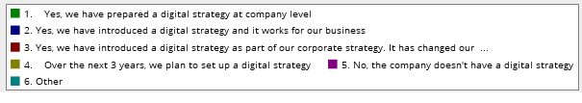
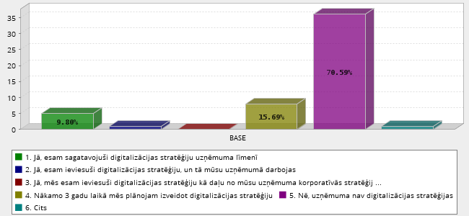

Table 17. Existence of the digitalization strategy
No | Answer | Count | Percent
1 | Yes, we have prepared a digital strategy at enterprise level | 5 | 9.80%
2 | Yes, we have introduced a digital strategy and it works for our business | 1 | 1.96%
3 | Yes, we have introduced a digital strategy as part of our corporate strategy. It has changed our business model | 0 | 0.00%
4 | Over the next 3 years, we plan to set up a digital strategy | 8 | 15.69%
5 | No, the enterprise doesn't have a digital strategy | 36 | 70.59%
6 | Other | 1 | 1.96%
 | Total | 51 | 100%

Digital skills of employees
Part of enterprises participating in the survey – 35% or 18 of 51 enterprises have employees with basic digital skills, while 25% or 13 of 51 enterprises have employees, whose digital skills are above the average; 14% or 7 of 51 enterprises have IT specialists in their enterprises; 12% or 6 of 51 enterprises hire IT specialists from other enterprises, while 12% or 6 of 51 enterprises think that employees of their enterprise don’t need digital skills. Please, see Picture 18 and Table 18.

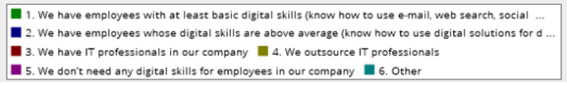
Picture 18. Digital skills of employees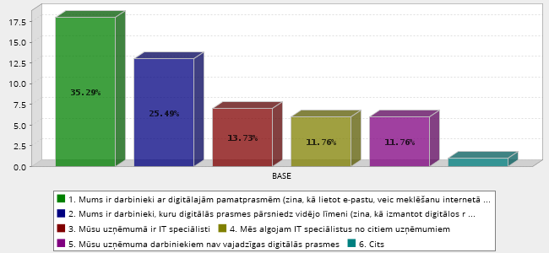

Table 20. Digital skills of employees
No | Answer | Count | Percent
1 | We have employees with at least basic digital skills (know how to use e-mail, web search, social networks, etc.) | 18 | 35.29%
2 | We have employees whose digital skills are above average (know how to use digital solutions for data exchange, accounting, digital marketing, sales and purchase, etc.) | 13 | 25.49%
3 | We have IT experts in our enterprise | 7 | 13.73%
4 | We outsource IT professionals | 6 | 11.76%
5 | We don’t need any digital skills for employees in our enterprise | 6 | 11.76%
6 | Other | 1 | 1.96%
 | Total | 51 | 100%

Results of evaluation and solutions for the digital transformation of enterprises

The survey provides a feedback for respondents about the state of digitalization of their enterprises if all survey questions are fully answered. Taking into account the responses received, all enterprises can be divided into five digitalization levels – from 0 (non-existent or very low) to 4 (very high). All together 51 enterprises took part in the survey by fully answering all questions and could be evaluated accordingly.

The results of evaluation indicate that none of the participants is on a very low (1st level) of the digitalization and the majority of enterprises 58% or 30 of 51 enterprises are above the average (4th and 5th levels). At the same time, only 12% or 6 of 51 enterprises have designed or introduced an enterprise level digitalization strategy (Table 19). Other part of enterprises or 42% or 21 of 51 enterprises have average or below average digitalization levels (2nd and 3rd levels), which means that they would still need to improve their digitalization level quite a lot, especially those 18% or 9 of 51 enterprises, which are still on the 2nd level of digitalization. Please, see Table 19.

Table 19. Level of digitalization of survey participants (51 enterprise)
No | Criteria | Level | No of  enterprises | %
0 | Organization does not have or doesn’t actively update its website, social networks and business-class e-mail. No organizational data is collected or analysed. | 1 | 0 | 0
1 | Some of the digitalization solutions are used – e-mail, collaborative environment, customer management, shared calendar, etc. The organization has a website but lacks any digitalization strategy. Ad-hoc digitalization projects are carried out only by enthusiasts. | 2 | 9 | 18
2 | Management supports ideas of implementing technology in operational processes. The organization has inter-functional cooperation – ex-change of data between departments, operational processes are being digitalized. The Digitalization strategy is created. Social media is being used. | 3 | 12 | 24
3 | The Digitalization strategy functions well. Everyone in the organization understands benefits of using digital technology. Understanding and managing clients’ needs takes place through technology. Automated tools and data ex-change. Proactive communication with the clients through digital channels. | 4 | 17 | 33
4 | The Digitalization strategy is on the level of vision and strategy of the organization. Management fully understands the importance of technology and guides its use. New products and services are created in the context of digital technology, which has changed the business model. | 5 | 13 | 25
 | Total: |  | 51 | 100

Answering a question about, what would be the most important three things needed for enterprises to promote the digital transformation in their enterprises, most of respondents – 21% or 24 of 51 enterprises think that they would need support programs for management and employees; training programs – 21% or 23 of 51 enterprises; and individual consultations – 19% or 21 of 51 enterprises. Other needs include a handbook with recommendations with practical examples, how the digitalization can improve businesses – 12% or 14 of 51 enterprises; employees with digital skills – 11% or 12 of 51 enterprises; brochures with information about different digital solutions – 7% or 8 of 51 enterprises; 5% or 6 of 51 enterprises think that nothing is needed; 3% or 3 of 51 enterprises think that information campaigns could be useful; and 2% or 1 of 51 enterprises thinks that other unspecified measures are needed. Please, see Picture 19 and Table 20.

Picture 19. Measures considered important for the digitalization of enterprises
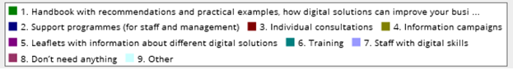
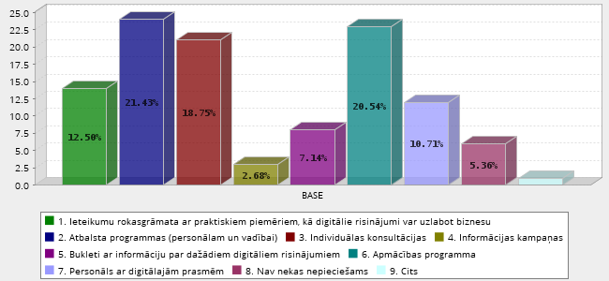

Table 20. Measures considered important for the digitalization of enterprises
No | Answer | Count | Percent
1 | Handbook with recommendations and practical examples, how digital solutions can improve your business | 14 | 12.50%
2 | Support programmes (for staff and management) | 24 | 21.43%
3 | Individual consultations | 21 | 18.75%
4 | Information campaigns | 3 | 2.68%
5 | Leaflets with information about different digital solutions | 8 | 7.14%
6 | Training | 23 | 20.54%
7 | Staff with digital skills | 12 | 10.71%
8 | Don’t need anything | 6 | 5.36%
9 | Other | 1 | 0.89%
 | Total | 112 | 100%

Summary

Most of respondents of survey or 82% are micro and small enterprises with up to 10 employees and turnover of 76% enterprises doesn’t exceed EUR 100 000. Enterprises participating in the survey are from a wide spectrum of economic sectors, except the ICT sector, which hasn’t been included in the target group of this survey. Participating enterprises are from all regions of Latvia with nearly half of enterprises coming from the Riga region, which is the most economically advanced region of Latvia.

This summary structures the information based on the survey answers according to four research questions formulated in the introductory part of this analysis.

Question 1. How small and medium businesses (SMEs) proceed towards the digital transformation?

According to the results of evaluation most of survey participants or 58% have above the average digitalization level for their enterprises, while other 42% have average or below average digitalization level, which means that quite many enterprises would still need to improve their digitalization performance quite extensively and would need an additional support for that.

Most of enterprises participating in this survey (71%) don’t have any corporate digitalization strategy. Only one enterprise has a fully functioning digitalization strategy; several enterprises (10%) have prepared their digitalization strategy on the enterprise level; and several enterprises (16%) are planning to develop their digitalization strategy within the next 3 years.
Part of enterprises participating in the survey (35%) have employees with basic digital skills, while others (25%) have employees, whose digital skills are above the average. Part of respondents (12%) think that their employees don’t need digital skills, while 14% have IT specialists in their enterprises; others (12%) hire IT specialists from other enterprises.
Nobody of respondents has a cyber-security strategy and only 61% use available digital security solutions. Mainly used digital security solutions are 1) different prophylactic measures against on-line attacks (22%); as well as 2) regular backups (21%); 3) data protection on all devices (20%); 4) management of logins (12%); 5) defence of business servers and applications (8%); 6) protected devices (8%); 7) regular trainings of employees on cyber security (7%s).

Question 2. Why and which digital solutions are being mostly used by SMEs?

Almost all enterprises, except one, consider digitalization beneficial for their businesses. Main benefits for enterprises are the following: new clients, increased turnover and profits, increased recognition for their businesses, as well as improved experience of their customers.
This survey reveals an interesting fact that entrepreneurs almost equally use mobile internet connection (43%) and fast speed broadband connection (41%), which indicates more preference for the mobile internet connection.

Majority of enterprises (84%) are satisfied with their internet connection and speed of internet for their daily business needs.

The top four digital technologies used by enterprises are 1) wireless technologies (38%); 2) Cloud data services (18%); 3) security (scripting) technologies (10%), and 4) data basis technologies (7%).

Most of enterprises are interested in introducing new digital technologies in their businesses. The four most desired digital technologies are: 1) databases technologies (15% or 14 responses); 2) big data / analytics (11% or 10 responses); 3) security / scripting (13% or 12 responses); 4) wireless technologies (11% or 10 responses).

The most commonly used IT solutions and services are: 1) data storage (28%); 2) data clouding services (21%); 3) on-line service solutions (13%); and 4) automatic generation of e-invoices (10%).

Those, who are planning to introduce new IT solutions or services in their businesses within the next 3 years, think that the most important are 1) automatic generation of e-invoices (22%); 2) on-line solution services (14%); 3) data clouding services (13%); 4) data storage (12%); 5) SEO solutions (10%); and 6) virtual service assistant (9%).

All respondents use the internet banking. Most of enterprises (82%) use public services portals or free public electronic tools. Those, who use public services, mainly use the public services’ portal Latvija.lv (41%); electronic signature (34%) and eID card (23%).

Users of e-commerce services (39%) mainly need them for 1) placing orders on-line (20%); 2) receiving orders from clients on-line (18%); 3) receiving orders on the website or application (15%); and 4) receiving orders on the computer (15%).

Most of enterprises (80%) use social media platforms for their businesses, mainly used are 1) social networks, such as Facebook, LinkedIn and others (37%); 2) own websites (33%); 3) blogs or microblogs, such as Twitter or Instagram (14%); 4) information storages, such as Google, Wikipedia and others (11%), 5) media co-working sites, such as You Tube, Slide Share and 6) others (4%).

Question 3. Why businesses don’t use particular IT solutions or technologies?
Enterprises, which aren’t planning to introduce new digital technologies in their businesses think that they aren’t needed for their enterprises or aren’t sure if this is necessary, or that they are too complicated, or don’t have enough information about these technologies.

Those enterprises, which don’t use any of IT solutions or services, have indicated that they are too expensive or not needed for their businesses, others consider IT solutions or services as too complicated or they don’t have employees that have necessary skills for using these IT solutions or services.

Enterprises, which aren’t planning to introduce any new IT solutions or services in their businesses, consider them too expensive or aren’t sure if they are needed for their businesses.

There is still a portion of enterprises (18%), which aren’t using public services’ portals or free public electronic tools. They consider that public services’ portals or free public electronic tools aren’t needed for their businesses; lack technical skills; or even think that they don’t use these possibilities, because the policy of enterprise doesn’t request to use them.

Those enterprises (30%), who don’t use any digital security solutions, mostly lack knowledge about digital security (50%) or consider it too complicated (10%), others think that they can manage their businesses without any digital security solutions (20%); or never heard about digital security solutions (15%); consider these solutions too expensive for their budgets (5%) or have other unspecified reasons.
Still, most of enterprises don’t use the e-commerce services to make orders on the Internet (61%). Therefore, this is especially important in the context of Covid19, to find out reasons of the non-use of e-commerce services. Part of respondents (32%) indicate that the main reason for the non-use of e-commerce is a lack of an overall e-commerce strategy in their enterprise. Several other responses emphasised too high product delivery / return costs; lack of foreign language knowledge; problems with product labelling, restrictions placed by business partners or clients and other unspecified reasons.

Those enterprises (20%), who don’t use social media tools, as the main reasons of non-use indicate that 1) they aren’t important for their businesses (30%); or 2) aren’t sure if they are needed for their businesses (20%); 3) that this is too complicated and time consuming (20%); 4) too expensive (10%), or 5) don’t have enough technical skills to use them (10%).
Question 4. How authorities can help businesses to promote the digital transformation process?
The three most important things needed for enterprises to promote the digital transformation in their enterprises are the following:
- support programs for management and employees (21%);
- trainings programs (21%);
- individual consultations (19%).

Other needs include a handbook with recommendations with practical examples, how the digitalization can improve businesses (12%); employees with digital skills (11%); brochures with information about different digital solutions (7%); only 5% think that nothing is needed; while some (3%) think that information campaigns could be useful.

Main Conclusions

On overall, the Latvian SMEs and microenterprises acknowledge the importance of digitalization and use digital tools & solutions quite actively. Most of enterprises are planning to introduce new digital technologies, solutions or services over the next three years. However, those enterprises, which are evaluated as having average or above the average digitalization levels would need an additional support to improve their digitalization development.

The survey has a particular influence of the Covid19 pandemic crisis which promoted the use of digital tools and solutions as many businesses, state institutions, schools and universities were forced to work remotely. Still, the level of digitalization in many enterprises still isn’t sufficient and need to be improved to ensure a long-term sustainability.

This study reveals that enterprises face a major problem on the strategic level taking into account that almost two thirds (71%) of enterprises don’t have any corporate digitalization strategy, nobody has any cyber-security strategy and only 61% use available digital security solutions. Which signals about problems on the management, strategy and planning levels of enterprises.

Latvian SMEs are quite familiar with digital technologies, as well as IT solutions and services, and benefits of social networks, which are being used by enterprises. Still, the use of e-commerce services is significantly lagging behind and reasons for that were only partly discovered by the survey. Also, almost one fifth of enterprises choose not to use public services’ portals or free public electronic tools.

The main identified reasons of non-use are: unawareness about digital technologies, IT solutions and services, digital security solutions, as well as their usefulness and benefits; lack of information, knowledge and skills; lack of funding; shortage of time; low priority with respect to digitalization or digital security issues; policy of enterprise; lack of digitalization strategy and overall e-commerce strategy.

Additional support, information, as well as individual couching is important for most of enterprises and particularly for those enterprises, which are evaluated as having average or below average digitalization level, as well as for those which still think that the digitalization isn’t needed for their businesses, because it is too complicated or they don’t have enough information about digitalization, or their employees don’t need digital skills at all.

Policy recommendations

In order to promote digitalisation and sustainability of Latvian SMEs and microenterprises, this is important to work with their managers to inform and convince them about advantages and benefits of digitalization. Focusing on strategic approaches for introducing digitalization and cyber-security strategies, including the e-commerce strategy, could provide enterprises with necessary foundation for their future growth and sustainability, as there has never been more important time for SMEs to have the digital strategies in place.

According to the results of survey the Government of Latvia should help to promote the digital transformation by creating and providing support programs for enterprises (focusing on strategic issues on the management level); training programs for developing digital skills, as well as individual consultations. For example, such support programmes, training and individual consultations could be provided through the network of 93 United State and Municipal Client Service Centres or regional offices of the development finance institution ALTUM. The support forms should be based on the identification of problems and needs of local enterprises through specially designed surveys or co-creation sessions.

This should be taken into account that obstacles for digitalization differ across Latvia. While the remote border areas still face problems with broadband connections and enterprises are struggling with funding to obtain modern technology, enterprises in other locations are more progressive and need more advanced forms of support, such as individual consultations, introduction with modern technologies and solutions, etc. Therefore, careful investigation of existing obstacles hindering digitalization of enterprises and identification of possible solutions in different locations is needed. At the same time, support programmes need to be flexible enough to provide tangible, as well as intangible benefits.

Taking into account that the use of e-commerce services is significantly lagging behind, the reasons of non-use of these services should be further deeply investigated in discussions with stakeholders and owners of SMEs. Also, possible solutions for making public services’ portals and free public electronic tools more useful and attractive for businesses (i.e. mobile applications) should be additionally discussed.

According to the survey results, this is recommendable to design a special handbook with recommendations and practical examples (good practices), how the digitalization can improve businesses and/or brochures with information about different digital solutions. Such handbook should be made available for enterprises free of charge.

In addition, other state institutions have to be involved in designing and implementing an overall national business digitalization programme or strategy under the coordination of the VARAM. According to the OECD, the digitalisation features prominently in national science, technology and innovation (STI) policy agendas, as part of main STI strategies or as dedicated national digital strategies, Industry 4.0 strategies or artificial intelligence (AI) strategies, which should be primarily also targeted in Latvia with respect to digital transformation. For this objective examples and good practices of other DigiBEST partner countries and regions, such as Austria or Portugal (Portugal Industry Program 4.0), can be used.

Additional work with available good practices of DigiBEST partners is needed to define if and how they could be used in Latvia. In addition, study visits (or on-line meetings) to the DigiBEST partner regions of a special interest in relation to good practices and exchange of experience are recommendable, when possible, taking into account the situation with the Covid19 pandemics and related restrictions. Also, Latvian experts and stakeholders should be involved in such study visits (or on-line meetings).

In order to facilitate the digital transformation, additional criteria could be introduced for those enterprises applying for the EU funds at the ALTUM. In this respect, a particular requirement for enterprises to have the digitalization strategy, including cybersecurity and e-commerce measures, as well as a plan for introducing this strategy, should be introduced for the business projects applying for the ALTUM financial instruments. Having such a strategy could provide a particular enterprise with additional points, when evaluating its business plan, and advance its perspectives for getting funding on better conditions in competition with other enterprises. Introducing such a requirement could be easily justifiable taking into account the fact that one of the priority areas of the Smart Specialization Strategy (RIS3) of Latvia is “Modern ICT” and the knowledge specialization area is “Information and communication technologies (ICT)”, both having an overall cross-cutting significance for the RIS3, as well as acknowledging the importance of digitalization for transformation of the national economy, as well as ensuring sustainable long term growth and prosperity.

Recently, the European Commission has proposed the creation of the first-ever Digital Europe Programme which will invest €9.2 billion to align the next long-term EU budget 2021-2027 with increasing digital challenges. In a series of workshops, the Commission together with the Member States have developed the way how European Digital Innovation Hubs (EDIHs) will be implemented within this programme. Member states will have to design potential hubs or use existing ones to apply for funding. In this case the VARAM with experts from other state organizations should investigate relevant DigiBEST practices and their usefulness for Latvia. For example, these could be the Austrian good practice on the Digital Innovation Hubs that was started already in 2018; Norwegian good practice “Public-private cooperation: Business gardens & Incubators: as a regional tool for digital transformation” and Portuguese good practice “Espaço Empresa / Business Space”.

Annex 1. DigiBEST survey questions

Introductory questions
Name of Enterprise
E-mail address
Website address
Business experience – year of establishing the company
Number of employees

1-10
11-50
51-100
101-200
200-250
Annual turnover (EUR)

1 – 10 000
10 – 30 000
30 000 – 100 000
100 000 – 500 000
500 000 – 1 000 000
Over 1 000 000
Industry/ business sector

Agriculture
Construction
Creative industries
Energy
Food and beverages production
Forestry
Industrial production
Legal, business and financial services
Machine building and metalworking
Media, advertising, education
Medicine and pharmacy
Real estate
Services
Trade
Transport and logistics
Tourism, hospitality entertainment
Other
Region / state / city

Questionnaire
1. Do you agree that your company will benefit from the improvement of digitalization level/digital transformation?
Yes/No

A. YES
What kind of digitalization benefits do you expect for your business? Please, select only three most important benefits/gains for your company.

- Increased turnover (profit)
- Acquired new customers
- Improved customer experience (service)
- Increased access to new foreign markets
- Improved data collection and analysis
- Increased number of innovations
- Consolidated (systematised) business processes and operations
- Reduced operating costs
- Empowered skills of workers
- Increased business visibility
- Other

B. NO
Please, indicate the reason why you disagree? Please, select only three most important reasons.

o Lack of information about digitalization benefits for my business
o Lack of confidence and trust in digitalization
o Lack of skills and competencies
o Lack of expertise
o Lack of IT infrastructure
o Lack of budget (too expensive)
o Other

2. What type of the Internet connection do you use for business? Please, select one.
- Phone line
- Mobile Connection
- Cable Internet
- Optical Internet (high speed broadband connection)
- Wi-Fi
- Satellite
- Other

3. Are you satisfied with the Internet connection for your business?
- The Internet connection is sufficient for daily business needs
- The Internet connection is too slow
- The Internet connection could be faster, but it is too costly for me to pay extra
- I can buy better and faster Internet connection if necessary
- Internet connection is not sufficient for my daily business needs, because the necessary infrastructure is not in place
- Don’t care about the Internet connection
- Other

4. Which of the following digital technologies have you introduced in your business today? Please, select three most important options.

- Sensors (ex: Light Dependent Resistor - LDR, Proximity Sensor)
- Wireless technology (ex: Wi-Fi)
- Automation technology (ex: Automated School Buses, Garage Opener Apps)
- Database technologies (ex: MySQL, PostgreSQL, Oracle)
- Big data / analytics (ex: Apache Hadoop, MapReduce)
- Machine learning / artificial intelligence (ex: Apple - Siri)
- Augmented reality / virtual reality / mixed reality (ex: AcrossAir, Google Sky Map, PokemonGo, VR glasses)
- Security / encryption
- Cloud computing (ex: Google App Engine, Apple iCloud)
- Data visualization (ex: Kumu.io, Google Chart Tools)
- Robots (ex: robot dog Aibo, the Roomba vacuum, AI-powered robot assistants)
- Drones (ex: video drones, military drones)
- Don’t use any of them
- Other

If you haven't introduced any digital technologies in your business. Please, specify:

- Don’t need them for my business
- They are too costly
- They are too complicated
- Don’t have information about them
- Don’t have employees with sufficient skills to use them
- Insecure
- Other

5. Which of the following IT solutions/and services do you use in your business?

- Virtual assistant for customer service (Amazon - Alexa virtual assistant, other virtual assistants)
- E-invoices that are eligible for automatic processing
- Data storage options (ex: Dropbox, One Drive, Google Docs)
- 3D printing capabilities (ex: 3D printer)
- Robot technology (ex: robot dog Aibo, the Roomba vacuum, AI-powered robot assistants)
- Cloud computing services (ex: Amazon EC2 — Virtual IT, Google App Engine — Application hosting, Google Apps and Microsoft Office Online — SaaS, Apple iCloud — Network storage)
- On-line solutions for services (ex. eSales)
- Digital marketing solutions (ex: CRM - Customer Relationship Management)
- SEO (Search Engine Optimization) solutions (ex: MailChimp)
- Don’t use any of them
- Other

If you don't use any IT solutions/and services. Please, specify:
- Don’t need them for my business
- They are too costly
- They are too complicated
- Don’t have information about them
- Don’t have employees with sufficient skills to use them
- Insecure
- Other

6. Which of the following digital technologies are you planning to introduce in your business during the next 3 years? Please, select three most important options.

- Sensors (ex: Light Dependent Resistor - LDR, Proximity Sensor)
- Wireless technology (ex: Wi-Fi)
- Automation technology (ex: Automated School Buses, Garage Opener Apps)
- Database technologies (ex: MySQL, PostgreSQL, Oracle)
- Big data / analytics (ex: Apache Hadoop, MapReduce)
- Machine learning / artificial intelligence (ex: Apple - Siri)
- Augmented reality / virtual reality / mixed reality (ex: AcrossAir, Google Sky Map, PokemonGo, VR glasses)
- Security / encryption
- Cloud computing (ex: Google App Engine, Apple iCloud)
- Data visualization (ex: Kumu.io, Google Chart Tools)
- Robots (ex: robot dog Aibo, the Roomba vacuum, AI-powered robot assistants)
- Drones (ex: video drones, military drones)
- Don’t use any of them
- Other
If you are not planning to introduce any digital technologies in your business. Please, specify why:

- Don’t need them for my business
- They are too costly
- They are too complicated
- Don’t have information about them
- Don’t have employees with sufficient skills to use them
- Insecure
- Other

7. Which of the following IT solutions and services are you planning to start using in your business during the next 3 years?
Please, select three most important options.

- Virtual assistant for customer service (Amazon - Alexa virtual assistant, other virtual assistants)
- E-invoices that are eligible for automatic processing
- Data storage options (ex: Dropbox, One Drive, Google Docs)
- 3D printing capabilities (ex: 3D printer)
- Robot technology (ex: robot dog Aibo, the Roomba vacuum, AI-powered robot assistants)
- Cloud computing services (ex: Amazon EC2 — Virtual IT, Google App Engine — Application hosting, Google Apps and Microsoft Office Online — SaaS, Apple iCloud — Network storage)
- On-line solutions for services (ex. eSales)
- Digital marketing solutions (ex: CRM - Customer Relationship Management)
- SEO (Search Engine Optimization) solutions (ex: MailChimp)
- Don’t use any of them
- Other
Please, specify the reason why:
- Don’t need them for my business
- They are too costly
- They are too complicated
- Don’t have information about them
- Don’t have employees with sufficient skills to use them
- Insecure
- Other

8. Do you use the Internet bank or on-line, or mobile banking solutions (such as Revolut, B26, etc.)?
- Yes
B. No

- Don’t need them for my business
- They are too costly
- They are too complicated
- Insecure
- Other

9. Do you use any public services Portal and electronically available free public tools?
YES/NO
If your answer was "Yes". Please, specify:

O Public services Portal (Each country specifies its e-government site)
o Digital signature (includes Digital signature and e-signature)
o E-IDcard
o Other
If your answer was "No". Please, specify:
o Have never heard about them
o Don’t have sufficient technical skills
o Insecure
o Complicated and time consuming
o Don’t need for my business
o It’s not required by public authorities
o Other
10. Has your company used e-commerce services to make purchases and sell on-line? Yes/No

Please, specify for what purpose your company used e-commerce. Select as many answers as you need.

- Have provided online ordering or reservation or booking, e.g. shopping cart via the website
- Have received orders via computer mediated networks
- Have received orders placed via EDI-type messages
- Have received orders via a website or apps (web sales)
- Have done electronic sales to the own country
- Have done electronic sales to other countries
- Have purchased via computer mediated networks
- Have purchased via computer networks from suppliers located in the own country
- Have purchased via computer networks from suppliers located in other countries
- Have been using software solutions like Customer Relationship Management (CRM)
- Other

Please, specify why your company does not use e-commerce.
Select as many answers as you need.
- High costs of delivering/returning products
- Problems related to resolving complaints and disputes
- Problems adapting product labelling
- Lack of knowledge of foreign languages
- Restrictions from business partners or customers
- Security concerns
- Not overarching strategy for e-commerce
- None of the above
- Other
11. Which of the following visibility and social media tools do you use for your business purposes?
Yes/No

Which of the following visibility and social media tools do you use for your business purposes?
- Website of company
- Blog, micro-blog such as Twitter or Instagram
- Media sharing sites like YouTube, Slide Share
- Information access networks such as Google, Wikipedia
- Social networks like Facebook, LinkedIn
- Don’t use any of them
- Other

Why don't you use visibility and social media tools?
- Have never heard about them
- Don’t have sufficient technical skills
- Too expensive (limited budget)
- Insecure
- Complicated and time consuming
- Don’t need them for my business
Other
12. Does your company use any digital security solutions?
Yes/No

What kind of digital security solutions does your company use? Please, select three most important options.
- Preventive measures from online attacks (https encryption, antiviruses, firewalls, etc.)
- Protection for business servers and applications
- Data protection across all devices
- Regular data backup
- Password managing tool
- Protected devices
- Staff regularly educated about cyber security
- Overarching strategy for cyber security
- Other

Why doesn't your company use any kind of digital security solutions?
- Don’t have expertise/knowledge on this issue
- It’s too complicated (lack of skills and competencies)
- I believe I can manage without digital security solutions
- Limited budget (too expensive)
- Have never heard about them
- Other

13. Does your company have a corporate digitalization strategy?

- Yes, we have prepared digitalization strategy at a company level
- Yes, we have implemented digitalization strategy and it is functional in our company
- Yes, we have implemented digitalization strategy as a part of our company’s corporate strategy. It has changed our business model
- We are planning to set up a digitalization strategy within the next 3 years
- No, we don’t have any digitalization strategy
- Other

14. Are your employees digitally literate? Please, select one answer.

- We have employees with at least basic digital skills (know how to use e-mail, web search, social networks, etc.)
- We have employees whose digital skills are above average (know how to use digital solutions for data exchange, accounting, digital marketing, sales and purchase, etc.)
- We have IT professionals in our company
- We outsource IT professionals
- We don’t need any digital skills for employees in our company
- Other

15. What would you need to promote the digital transformation of your company? Please, select the three most important options.
- Handbook with recommendations and practical examples, how digital solutions can improve your business
- Support programmes (for staff and management)
- Individual consultations
- Information campaigns
- Leaflets with information about different digital solutions
- Training
- Staff with digital skills
- Don’t need anything
- Other

Annex 2. Definitions used in the survey

Digitalization is the use of digital technologies to change a business model and provide new revenue and value-producing opportunities. (Source: Gartner IT service management company: https://www.gartner.com/en/information-technology/glossary/digitalization)
Digital transformation is a broad concept encompassing the changes induced by the increased availability and use of digital technologies in almost all kind of human activities. For businesses – and this our focus in this article – it implies that existing or emerging digital technologies contribute to change their business models, their products or services and the way they are manufactured and delivered, as well as the necessary skills to remain competitive in fast changing competitive environments. (Source : EC Interreg Europe: https://www.interregeurope.eu/policylearning/news/3917/digital-transformation-scoreboard-2018-are-eu-companies-adopting-digital-technologies/)
E-commerce can be defined generally as the sale or purchase of goods or services, whether between businesses, households, individuals or private organizations, through electronic transactions conducted via the internet or other computer-mediated (online communication) networks. The term covers the ordering of goods and services which are sent over computer networks, but the payment and the ultimate delivery of the goods or service may be conducted either on- or off-line. (Eurostsat: https://ec.europa.eu/eurostat/statistics-explained/index.php/Glossary:E-commerce)
Sensors (ex: Light Dependent Resistor - LDR, Proximity Sensor). Device that responds to a physical stimulus (such as heat, light, sound, pressure, magnetism, or a particular motion) and transmits a resulting impulse (as for measurement or operating a control) (Source: Webster's Dictionary: https://www.merriam-webster.com/dictionary/sensor)
Wireless technology (ex: Wi-Fi)
Networking technology that uses radio waves to allow high-speed data transfer over short distances.) (Source: The Encyclopaedia Britannica: https://www.britannica.com/technology/Wi-Fi
Automation technology (ex: Automated School Buses, Garage Opener Apps)
Automatically controlled operation of an apparatus, process, or system by mechanical or electronic devices that take the place of human labour. (Source: Webster's Dictionary: https://www.merriam-webster.com/dictionary/automation.)
Database technologies (ex: MySQL, PostgreSQL, Oracle)
Database technologies take information and store, organize, and process it in a way that enables users to easily and intuitively go back and find details they are searching for. (Source: The Encyclopaedia Britannica: https://www.britannica.com/technology/database)
Big data / analytics (ex: Apache Hadoop, MapReduce)
An accumulation of data that is too large and complex for processing by traditional database management tools (Source: Webster's Dictionary: https://www.merriam-webster.com/dictionary/big%20data)
Machine learning / artificial intelligence (ex: Apple - Siri, virtual assistants)
Discipline concerned with the implementation of computer software that can learn autonomously. (Source: The Encyclopædia Britannica: https://www.britannica.com/technology/machine-learning)
Augmented reality / virtual reality / mixed reality (ex: AcrossAir, Google Sky Map, PokemonGo, VR glasses).
Augmented reality is an enhanced version of reality created by the use of technology to overlay digital information on an image of something being viewed through a device (such as a smartphone camera).
Virtual reality is an artificial environment which is experienced through sensory stimuli (such as sights and sounds) provided by a computer and in which one's actions partially determine what happens in the environment.
Source: Webster's Dictionary: https://www.merriam-webster.com/dictionary/augmented%20reality; https://www.merriam-webster.com/dictionary/virtual%20reality
Virtual assistant for customer service (ex: Apple - Siri, Amazon - Alexa virtual assistant)
A virtual customer assistant (VCA) is a business application that simulates a conversation in order to deliver information and, if advanced, takes action on behalf of the customer to perform transactions. (Source: Gartner IT service management company: https://www.gartner.com/en/information-technology/glossary/virtual-assistant-va)
Security / encryption
Data encryption, also called encryption or encipherment, the process of disguising information as “ciphertext,” or data unintelligible to an unauthorized person. (Source: The Encyclopaedia Britannica: https://www.britannica.com/technology/data-encryption)
Cloud computing (ex: Google App Engine, Apple iCloud)
Method of running application software and storing related data in central computer systems and providing customers or other users access to them through the Internet. (Source: The Encyclopaedia Britannica: https://www.britannica.com/technology/cloud-computing)
Data visualization (ex: Kumu.io, Google Chart Tools)
Process of interpreting in visual terms or of putting into visible form. (Source: Webster's Dictionary: https://www.merriam-webster.com/dictionary/visualization)
Robots (ex: robot dog Aibo, the Roomba vacuum, AI-powered robot assistants)
Any automatically operated machine that replaces human effort, though it may not resemble human beings in appearance or perform functions in a humanlike manner (Source: The Encyclopaedia Britannica: https://www.britannica.com/technology/robot-technology)
Drones (ex: video drones, military drones)
An unmanned aircraft or ship guided by remote control or on-board computers. (Source: Webster's Dictionary: https://www.merriam-webster.com/dictionary/drone)
3D printing capabilities
The manufacturing of a three-dimensional product from a computer-driven digital model. (Source: Business Dictionary: http://www.businessdictionary.com/definition/3d-printing.html )
SEO solutions (ex: Search Engine Optimization)
The process of maximizing the number of visitors to a particular website by ensuring that the site appears high on the list of results returned by a search engine. (Source: Lexico: https://www.lexico.com/definition/search_engine_optimization)
Sensors (ex: Light Dependent Resistor - LDR, Proximity Sensor). Device that responds to a physical stimulus (such as heat, light, sound, pressure, magnetism, or a particular motion) and transmits a resulting impulse (as for measurement or operating a control) (Source: Webster's Dictionary: https://www.merriam-webster.com/dictionary/sensor)
Wireless technology (ex: Wi-Fi)Networking technology that uses radio waves to allow high-speed data transfer over short distances.) (Source: The Encyclopaedia Britannica: https://www.britannica.com/technology/Wi-Fi)
Automation technology (ex: Automated School Buses, Garage Opener Apps) Automatically controlled operation of an apparatus, process, or system by mechanical or electronic devices that take the place of human labour. (Source: Webster's Dictionary: https://www.merriam-webster.com/dictionary/automation.)
Database technologies (ex: MySQL, PostgreSQL, Oracle) Database technologies take information and store, organize, and process it in a way that enables users to easily and intuitively go back and find details they are searching for. (Source: The Encyclopaedia Britannica: https://www.britannica.com/technology/database)
Big data / analytics (ex: Apache Hadoop, MapReduce) An accumulation of data that is too large and complex for processing by traditional database management tools (Source: Webster's Dictionary: https://www.merriam-webster.com/dictionary/big%20data)
Machine learning / artificial intelligence (ex: Apple - Siri, virtual assistants) Discipline concerned with the implementation of computer software that can learn autonomously. (Source: The Encyclopaedia Britannica: https://www.britannica.com/technology/machine-learning )

According to the project methodology Similar Regional Studies, as well as surveys, are being conducted by all 6 project partners. Results of these studies and surveys will be further used throughout the project implementation according to the Application form.
https://www.varam.gov.lv/lv/valsts-un-pasvaldibas-vienotais-klientu-apkalposanas-centru-tikls
https://www.altum.lv/en/contacts/#map-section
http://www.oecd.org/sti/science-technology-innovation-outlook/digital-innovation-and-inclusiveness/
According to the Interreg Europe definition “The good practice is defined as an initiative (e.g. methodology, projects, processes, techniques) undertaken in one of the programmes thematic priorities which has already proved successful and which has the potential to be transferred to a different geographic area. Proved successful is where the good practice has already provided tangible and measurable results in achieving a specific objective.” All good practices collected in the DigiBEST framework will be published on the Interreg Europe Policy Learning platform: https://www.interregeurope.eu/policylearning/
https://izm.gov.lv/en/Science/smart-specialisation-strategy
https://ec.europa.eu/digital-single-market/en/digital-innovation

