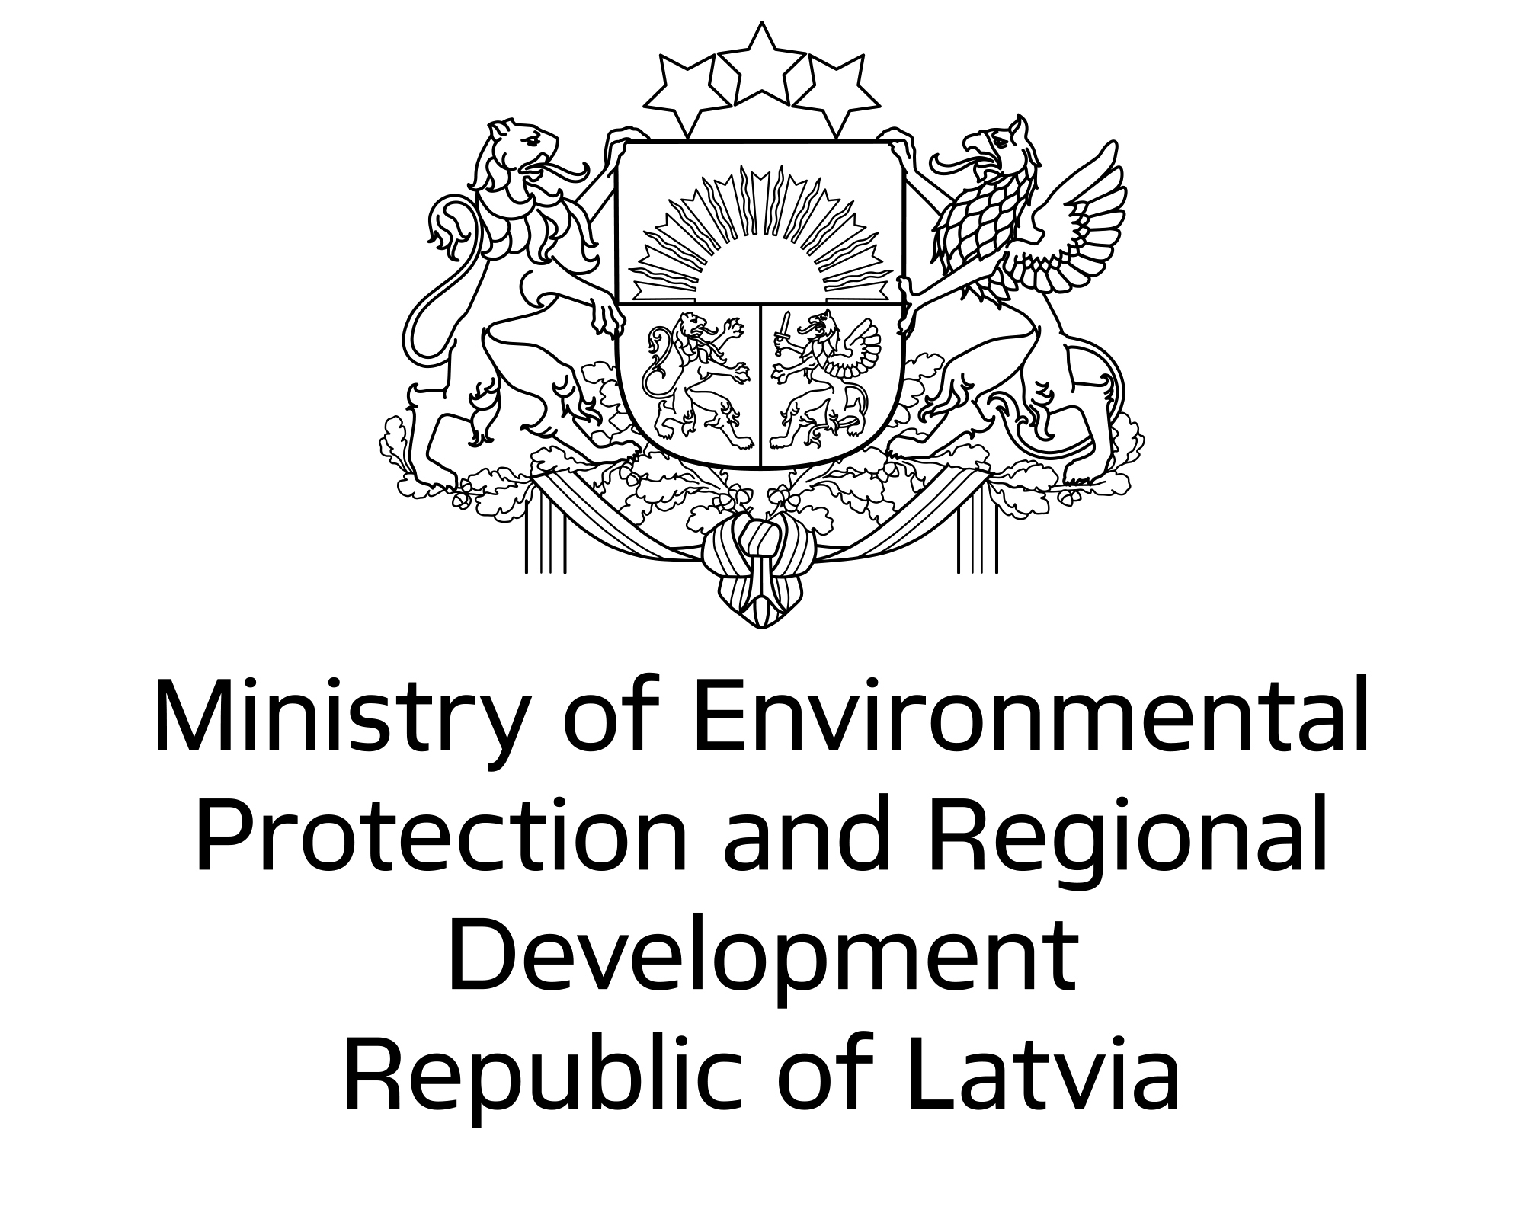
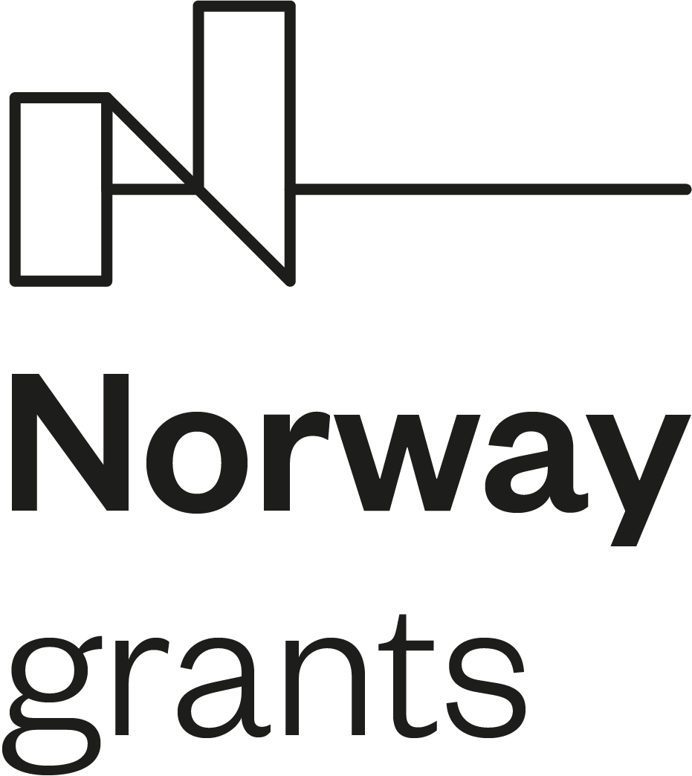

Project Partner Search Form for potential Norwegian partners

Open Call “Mitigation of Risks Related to Historically Contaminated Sites”*
Identification of the potential partner
Name of the organisation
Registered address (street, city, country)
Telephone / Fax
Website of the organisation
Name of the contact person
Email/Telephone of the contact person
Short presentation of your organisation (key activities, experience)
Proposal for cooperation
Offer for activities and experience in the fields covered by this Open Call
Role of potential partner
Other relevant information
Date
The offer is valid until**
*More detailed information can be found in the Open Call documentation: https://eeagrants.lv/en/2020/06/03/mitigation-of-risks-related-to-historically-contaminated-sites/
**Deadline for submitting Open Call project proposals: 7 December 2020

